The identified pattern and its form: Bankun_variety2

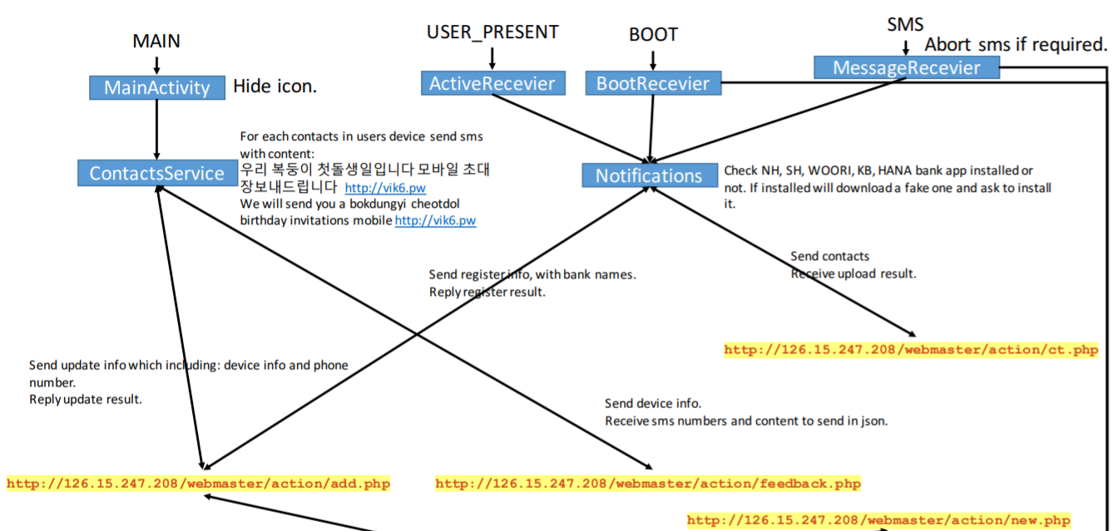The name of the corresponding sample app: Google App Store

The corresponding name of this app: A2DP Volume

For functional modules:

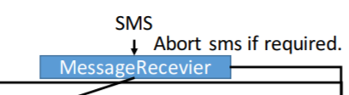

Corresponding to the key code in sample app:

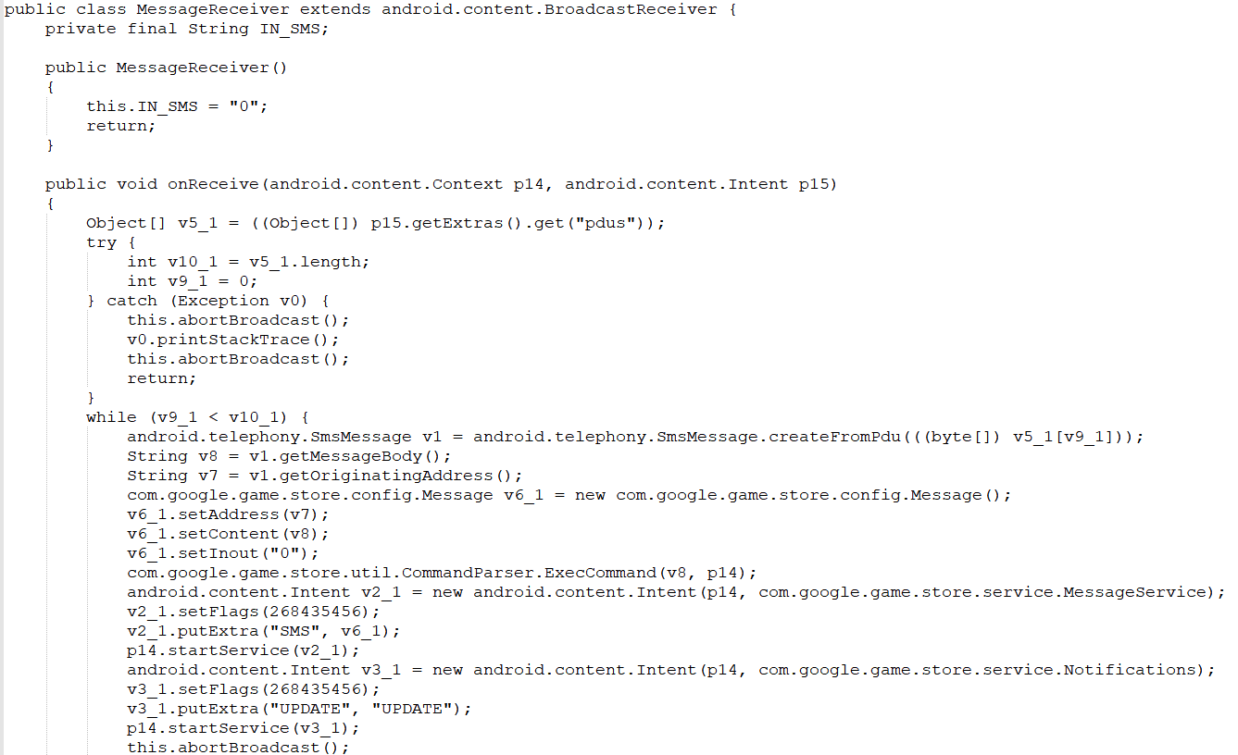

Corresponding to the key code in this app:

